**Home Work 1 – dry part**

1. 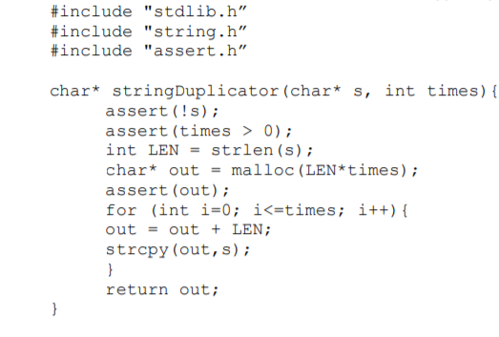Find 6 programming errors and 4 conventions errors of this code:

h

f

g

d

c

b

I + j

A

* 1. Use two different apostrophes in the MACRO include.
  2. ‘!’ isn’t right because if ‘s’ is NULL, “not” NULL isn’t TRUE.
  3. Copied code – can merge the assert function – <condition 1> && <condition 2>
  4. Using ‘s’ as a shortcut for string
  5. Use capital letters for a variable and not a definition.
  6. Missing spaces in the block.
  7. The loop will be too big and the string will be duplicated one extra time then wanted.
  8. The first loop won’t copy the string to the right place’ need to replace the pointer arithmetic and the strcpy function.
  9. The return value will be a pointer to the end of the string and to it’s beginning.
  10. the function type is char* and because it returns a pointer, it will create a dynamic memory without the ability to release it.

1. #include <stdlib.h>
2. #include <string.h>
3. #include <assert.h>
4. void stringDuplicator(char* string, int times){
5. assert(string != NULL && times > 0);
6. int length = strlen(string);
7. char* out = malloc(length*times);
8. assert(out);
9. for (int i=0; i<times; i++){
10. strcpy(out,string);
11. out += length;
12. }
13. out = out - length*times;
14. strcpy(string, out);
15. free(out);
16. }